**Project 2 - Calculating Hubble constant using Type-1a Supernovae**

Justin M. Lewis, O’Brein Carr, Abdullahi Omar

The Ohio State University

ASTRON 1221: Astronomy Data Analysis

Dr. Ji Wang

October 20, 2024

**Abstract**

Using the equation $$H_{0}$$ = $$\frac{v}{D}$$, we can find the Hubble constant from the recessional velocity and the distance from the observation point, which in our case is Earth. The equation used is called Hubble’s Law which states that the recessional velocity is proportional to the distance from the observation point. The law provides the Hubble constant which can be used to calculate the age of the universe, as it is simply the reciprocal of Hubble’s constant.

**Motivation**

Our team wanted to find the speed at which the universe expands. This motivation is the driving factor as to why our team needed to understand Hubble’s Law, for it states that galaxies are moving away from the observation point (Earth) at a speed that is proportional to their distance. In our team’s case, we wanted to find the speed at which our universe is moving away from us. This speed D indicates the age of our known universe because the speed at which it expands proportional to its distance is the age of the universe.

**Methods**

Our team employed the use of the known Hubble’s Law equation (*Figure 1.1*) and the provided data of Type-1A Supernova to calculate our own Hubble constant that we would then use to solve for the age of the universe. We began by plotting the data in a linear scale in *Figure 1.2,* along with error bars to show the uncertainty and the variability within our given data. After getting the linear scale plot, we then used the slope to get the Hubble constant. Finally using the Hubble constant to find the age of the universe. One thing we tried to do was get the average of the velocity and distance column. Then using the average to try and get a Hubble constant. The problem with this method was that it was accounting for all data outside of the linear plot. This causes the Hubble constant to be larger than the Hubble Constant found using the slope. Although the difference did not look like much, only being about .25 it caused for our Age of the Universe to be off by about 53 million years. This is comparing it to the age of the universe we got using the slope.

Figure 1.1

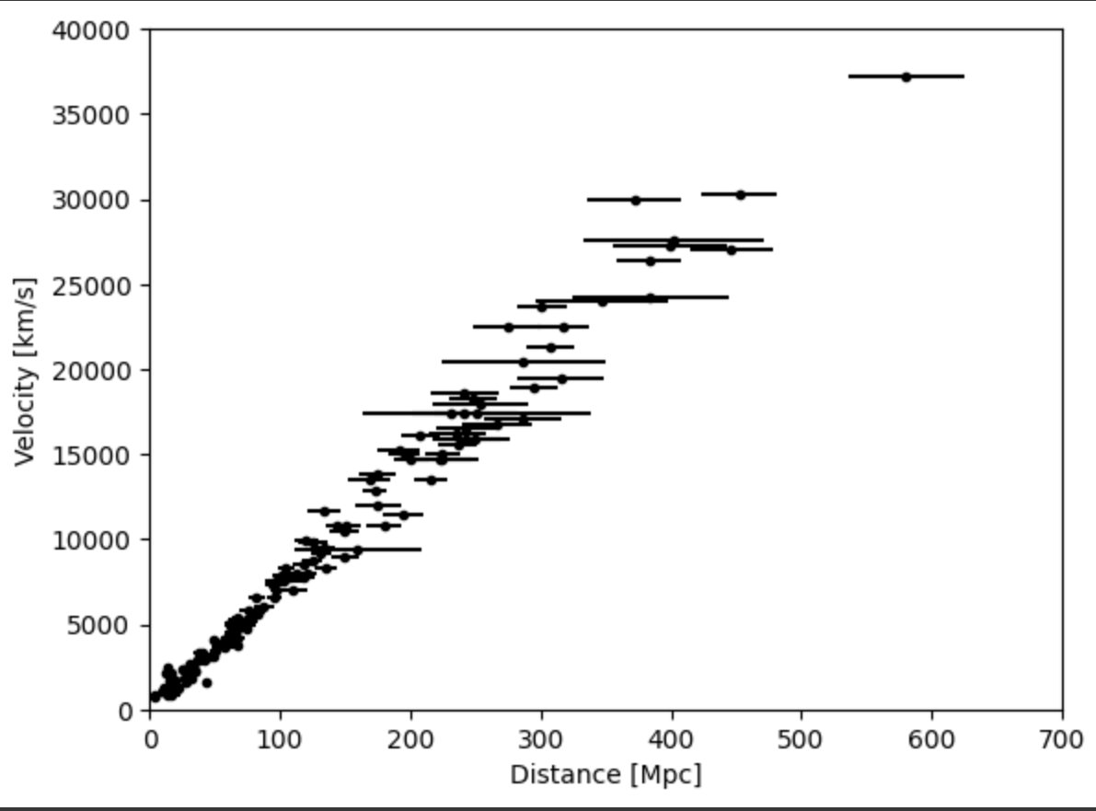

Figure 1.2

**Results**

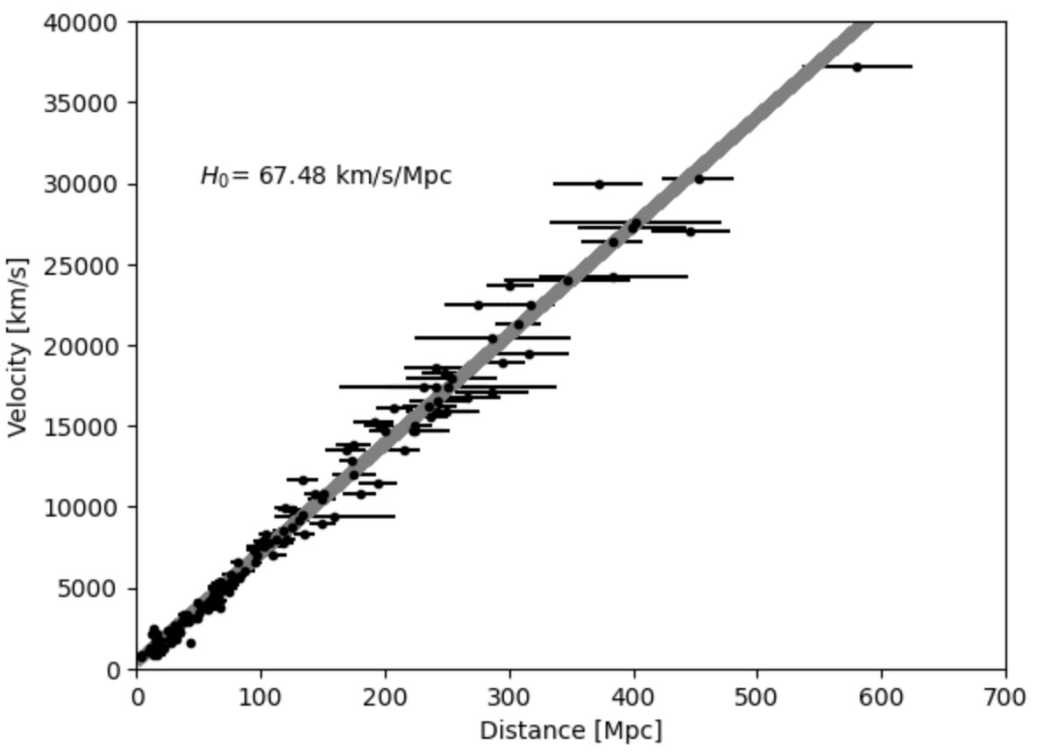

Figure 1.3

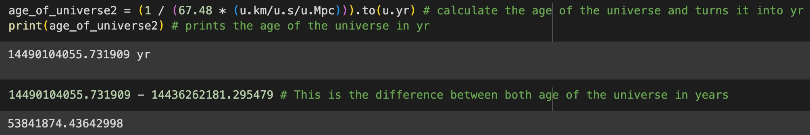Figure 1.4

**Conclusion (Are Results Sensible)**

Using Hubble’s Law, we were able to get the Hubble constant of the universe. This value determines the rate at which the universe is expanding at a decelerating rate or at an accelerating rate. Through the data graphing, we used the slope of the graph to get a more accurate Hubble Constant. Using this we were able to determine the age of the universe. Finally, we used the reduced chi-squared to determine how accurate our graph was with the data. We used Gemini to fix our reduced chi-squared to get a more accurate number to show how accurate our graph was.

**Contribution Statements**

**AI Statement**

We used Gemini to help make a more accurate reduced chi-squared function. This is because our function for the reduced chi was not precise enough and it gave us a number that was above 30,000. With the use of Gemini, we reduced that value to about 13.5. Which is more accurate since the closer your answer is to one the more precise your graph is to the data. If the number is below one that means your graph is overfitted and the further from one, it is the less your data fits.

**References/Citations**

**"Reduced Chi-Squared" prompt. Gemini, Google, 8 Nov. 2023, colab.research.google.com.**

**Kirshner, R. P. “Hubble’s Diagram and Cosmic Expansion.” Proceedings of the National Academy of Sciences, vol. 101, no. 1, 26 Dec. 2003, pp. 8–13, https://doi.org/10.1073/pnas.2536799100.**

**Tonry, John L., et al. “Cosmological Results from High‐ZSupernovae.” The Astrophysical Journal, vol. 594, no. 1, Sept. 2003, pp. 1–24, https://doi.org/10.1086/376865. Accessed 21 Oct. 2019.**

**https://github.com/wj198414/ASTRON1221/blob/1c1e08f561072d878a167af4cc2950851317f18c/DarkEnergy/Tonry_2003.vot**